# Boolean Operators with NumPy

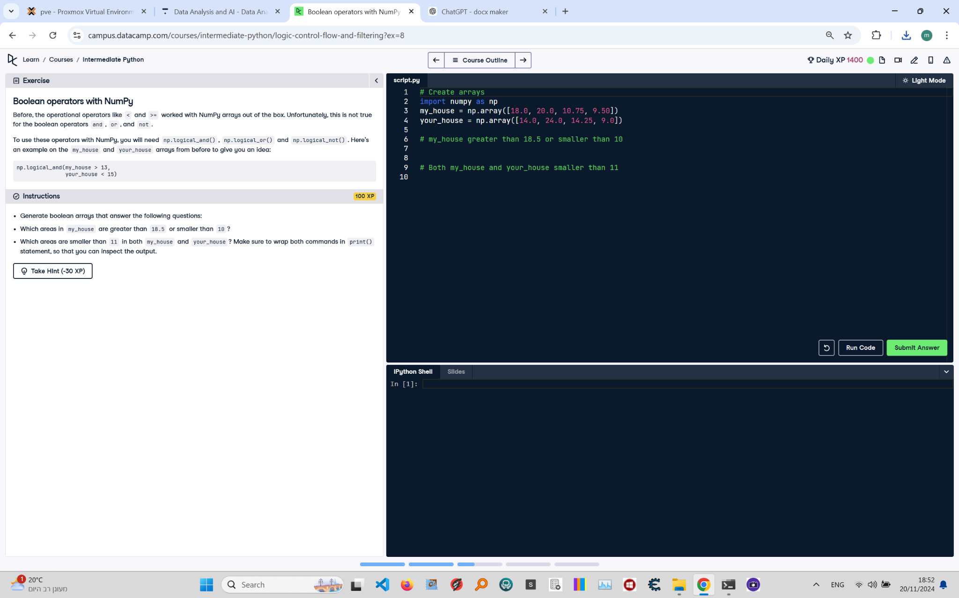

**Question:**

Generate boolean arrays that answer the following questions:  
1. Which areas in `my_house` are greater than 18.5 or smaller than 10?  
2. Which areas are smaller than 11 in both `my_house` and `your_house`?  
Make sure to wrap both commands in a `print()` statement so that you can inspect the output.

**Answer:**

Here is the Python code that solves the problem:

# Create arrays  
import numpy as np  
  
my_house = np.array([18.0, 20.0, 10.75, 9.50])  
your_house = np.array([14.0, 24.0, 14.25, 9.0])  
  
# my_house greater than 18.5 or smaller than 10  
print(np.logical_or(my_house > 18.5, my_house < 10))  
  
# Both my_house and your_house smaller than 11  
print(np.logical_and(my_house < 11, your_house < 11))

**Explanation:**

1. **Import NumPy**: The `numpy` library is imported to perform operations on arrays.  
2. **Define arrays**: `my_house` and `your_house` represent the areas for different rooms in two houses.  
3. **Logical OR operation**: The `np.logical_or(my_house > 18.5, my_house < 10)` checks which areas in `my_house` are either greater than 18.5 or smaller than 10, returning a boolean array.  
4. **Logical AND operation**: The `np.logical_and(my_house < 11, your_house < 11)` checks which areas are smaller than 11 in both `my_house` and `your_house`, returning a boolean array.  
5. **Print results**: The results of both boolean operations are printed for inspection.